**Report**

The Object oriented solution to the problem defines , the code have database files that are named as Order.txt , Customer.txt , Product.txt that contains the relevant information regarding the software .

There is a menu in main screen that have 5 options as shown in image

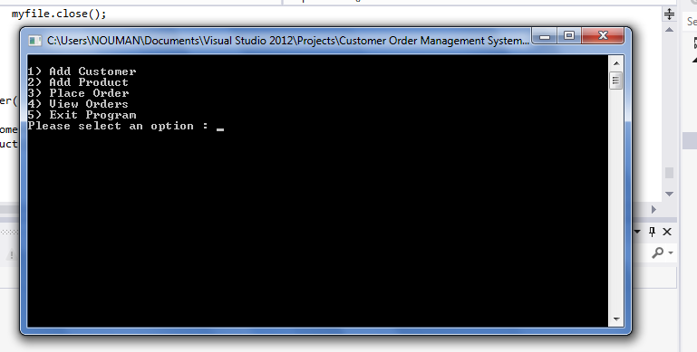

then user selects the relevant module and works on it .Suppose user want to see order placed he pressed 4 then the following screen shows the output of files

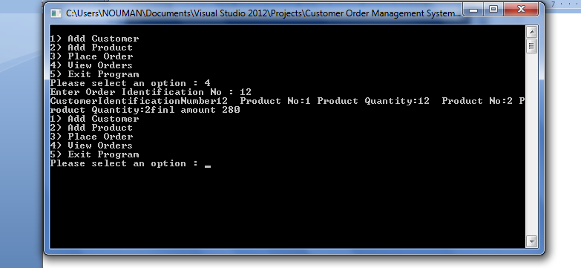

Here is the output of order against no 12 .

There is no duplication allowed to enter the customer or product against the same ID

The solution to the problem contains 1 main function that call the related function written in the same file Main.cpp and the following libraries are used

#include <iostream>

#include <string>

#include <sstream>

#include <fstream>

#include <iomanip>

using namespace std;

The source code also read and write to files in OBJECT ORIENTED Methodology